Last Updated: 2/12/2024
This Quick Reference Guide (QRG) outlines the One-up Compensation Manager’s process of accessing, reviewing, and submitting a Merit Planning Worksheet for completion.
- As soon as a Compensation Manager completes a Merit Planning Worksheet, it will be routed to the One-up Compensation Manager for the 1st Level Merit Review.
- The One-up Compensation Manager will receive an email stating that the worksheet is ready for review.

For additional details regarding the responsibilities of the Compensation Manager (whose worksheets One-up Compensation Managers are tasked with approving) please see the Merit Planning for Compensation Managers QRG.

Contents (Quick Links)
Accessing the Merit Planning Worksheet for Review 1
Reviewing the Merit Planning Worksheet 2
Returning to Previous Step / Sending to Next Step 3
Form Status Information 4
Merit Planning Reports 5
Export Merit Worksheet 5
Export Detailed and Rollup Reports 5
Viewing Batch Processed Reports 7

Accessing the Merit Planning Worksheet for Review
One-up Compensation Managers receive an email when there is a Merit Planning Worksheet available for approval. The email contains a link to access the Worksheet. The steps below are an alternative way to access the Worksheet.
Individuals with multiple positions may encounter issues clicking the link in the email message. Please use the instructions below.
Via the OneCampus portal (one.purdue.edu), select Employee Launchpad

Log in using Purdue Career Account ID and Password..
Click the Plan Compensation To-Do tile | 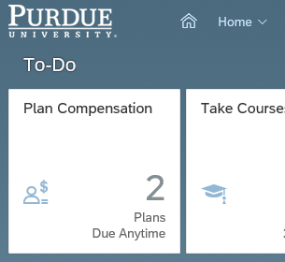
If you hold multiple positions and do not see the Plan Compensation tile, use the Change Selected Employment icon to select the appropriate position. | 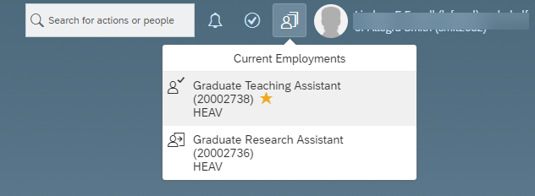
Choose the link for 1st Level Merit Review of the target individual’s Merit Worksheet. | 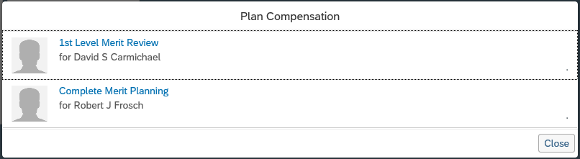
The Merit Planning Worksheet displays. | 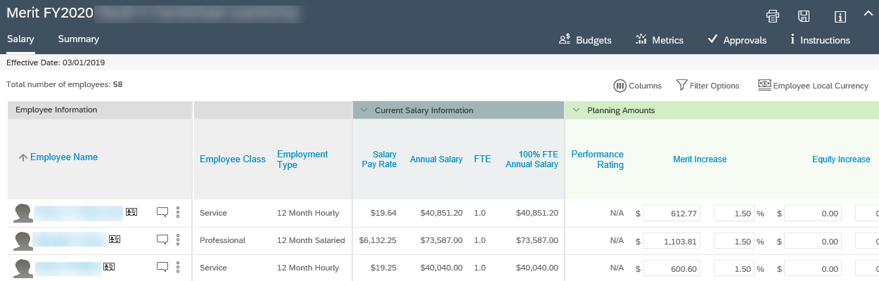

Reviewing the Merit Planning Worksheet
Since One-Up Compensation Managers are charged with completing worksheets as well, this section assumes that the individual reviewing the Merit Planning Worksheet has an understanding of the functions and features of the worksheet. To review the functions and features of the worksheet, please see the Merit Planning for Compensation Managers QRG.
Review Merit and Equity Increases recommended by the Compensation Manager.  Use the Budgets widget to verify adherence to allocated funds.  Use the Metrics widget to ensure consistency between performance rating and recommended increase.  Add Extra Merit if appropriate / allowable by area practice. | 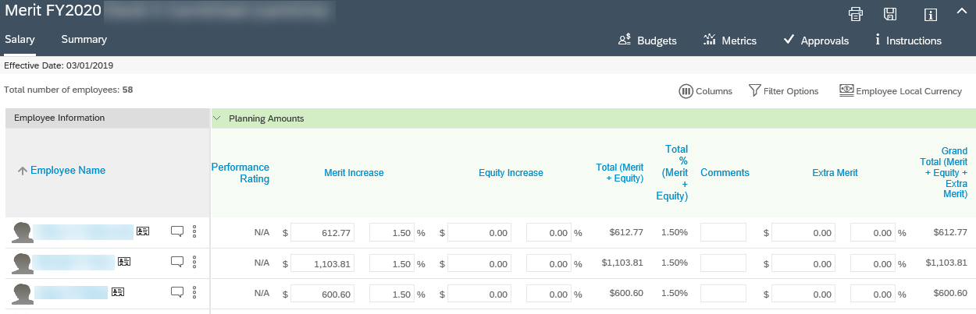
Review New Salary Information. | 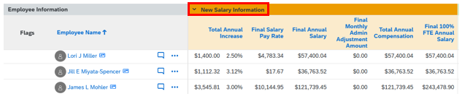
Review any other data as desired, ensuring compliance with budget/salary policy.

Returning to Previous Step / Sending to Next Step
If any changes have been made, click Save. | 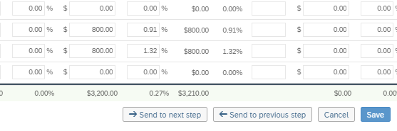
If sending to previous step (changes needed):

Click Send to previous step
If sending to previous step (changes needed):  - Include a comment informing the Compensation Manager of the desired adjustments.  - Click Send to previous step | 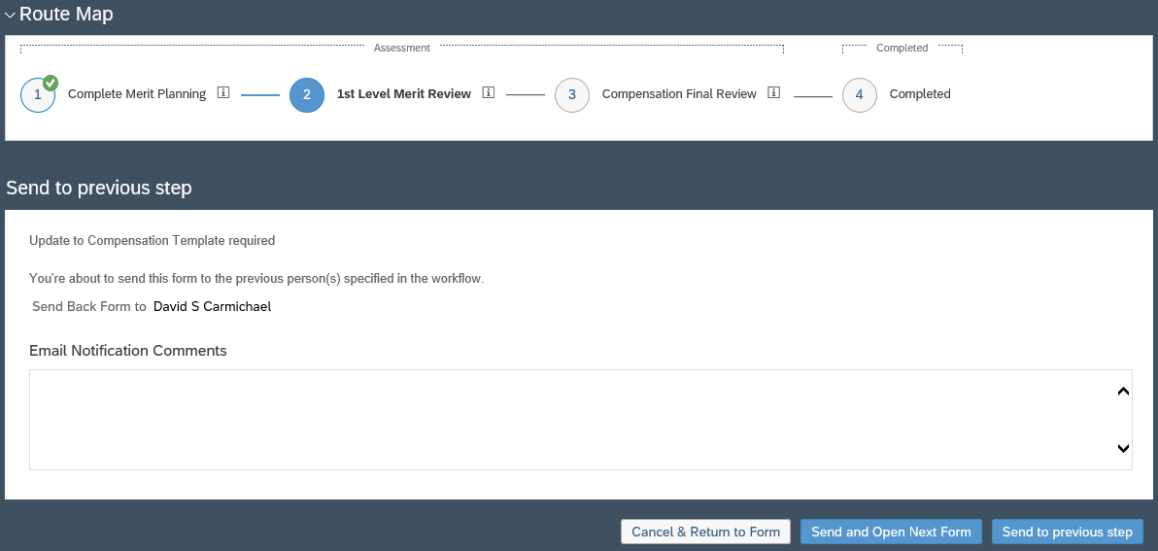  2  1
If sending to next step (completion):

Click Send to next step
If sending to next step (completion):  The form will be submitted to the Compensation team for implementation.  - Include a comment if needed.  - Click Send to next step | 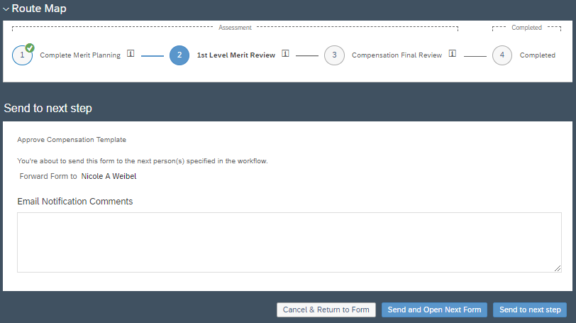  2  1

Form Status Information
Status of Forms are always available in the Forms section.
- From the Home menu, select Compensation  - In the menu bar, click Forms | 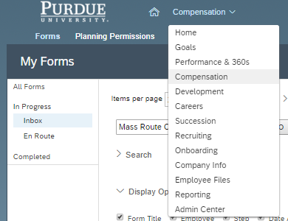  1  2
Completed: Forms have been submitted to the Compensation team and accepted (forms will not show as Completed until after the worksheet due date – all will be accepted at the same time).  En Route: Forms are pending approval with the individual listed in the Currently With column. | 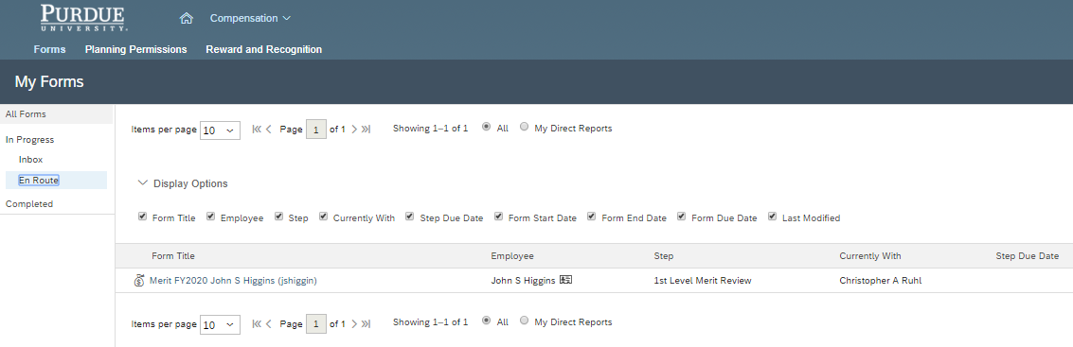

Merit Planning Reports
This section outlines the reporting and exporting functionalities available to Compensation Managers during and following the Merit Planning process.

Export Merit Worksheet
If you wish to export the worksheet to review the information, please follow the step below.
Note: Worksheets cannot be imported.
Click the Summary tab.  Click Export as MS Excel. |  |  | 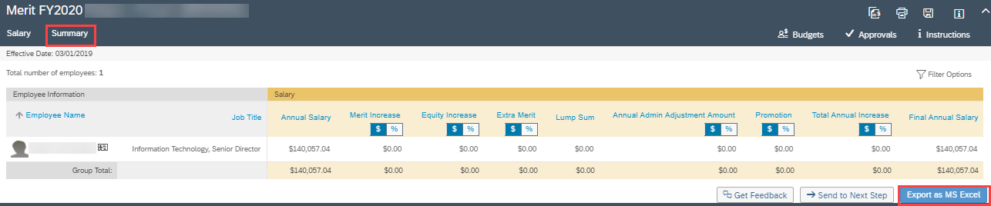

Export Detailed and Rollup Reports
These reports provide the aggregate of total values of all users in the Compensation Manager hierarchy below the individual selected. The reports allow for drill-down to other users and review of specific Compensation worksheets. These reports cannot be edited and imported back into the Compensation module.
- From the Home menu, select the Compensation module  - Click the Forms tab  - Select All Forms |  | 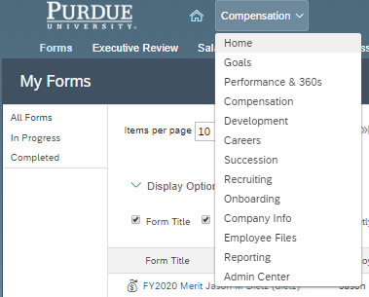  3  2  1
In the Action column, click the Detailed Report icon  () |  | 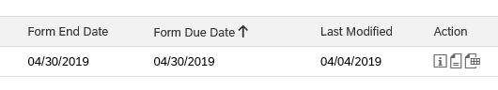
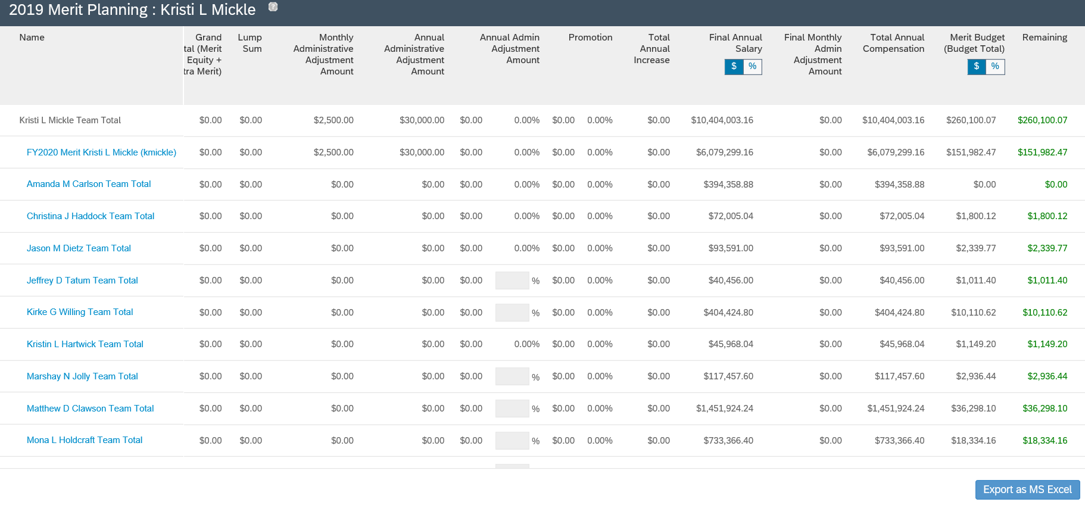
4
3
2
1
The Team Totals report is displayed for yourself and all Compensation Managers below you (in the Compensation Manager hierarchy). Some helpful features of the report are:
1 | Click each Team Total link to drill into the worksheets.
2 | Option to view the data in $ or %
3 | Columns found on the far right of the worksheet outline the budget utilized and remaining
4 | Option to Export to MS Excel (additional details on this process begin with the next step of this document)
To export a detailed and rollup version of this report, click Export as MS Excel |  | 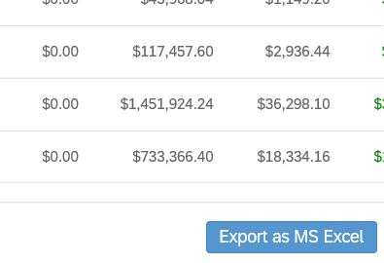
If an error message is displayed stating that the report has been scheduled for batch processing, see the Viewing Batch Processed Reports section of this document.  This message is typically displayed when more than 1000 records are being exported. |  | 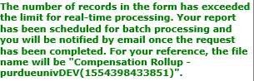
Save the zipped folder.
Two reports will appear in the folder:  - Compensation Rollup - Details  - Compensation Rollup - Rollup |  | 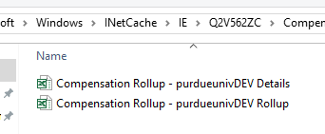
Compensation Rollup – Details displays the expanded view of all worksheets listed and all individuals listed on each worksheet. |  | 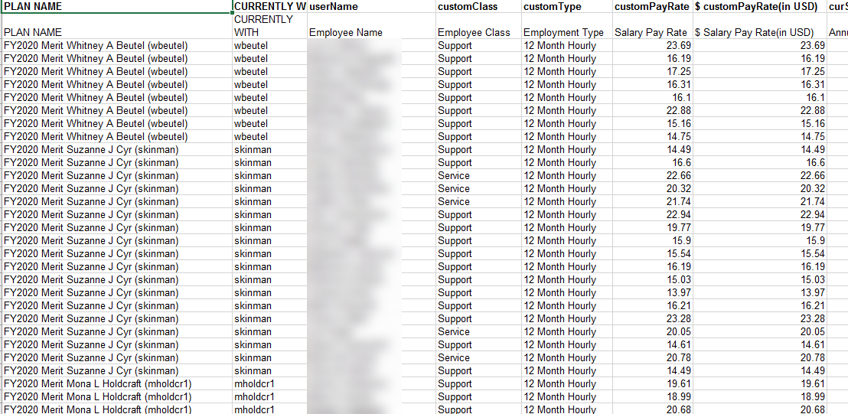
Compensation Rollup – Rollup displays the rollup of each Compensation Manager’s worksheet listed (no individual detail), with budget used, percentage, and budget remaining. |  | 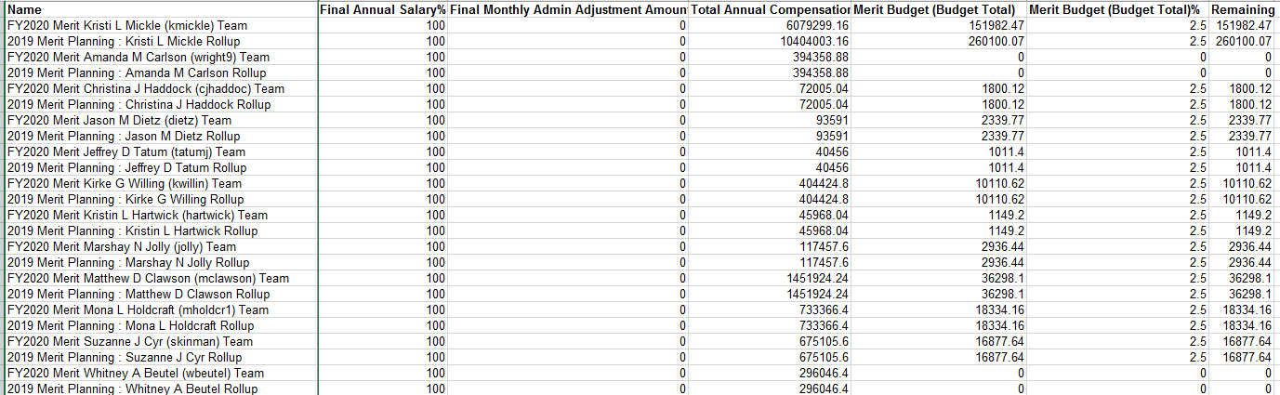

Viewing Batch Processed Reports
If attempting to export a large report, it may be scheduled for batch processing. This section outlines how to retrieve the report.
Use the Home menu to access the Reporting module. | 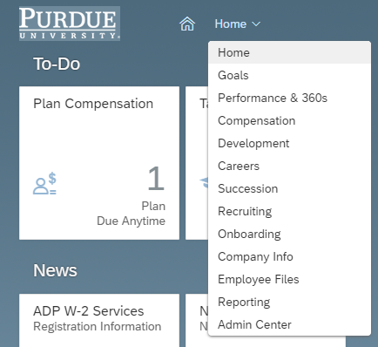
Click Switch to Classic View
Click Scheduled Reports  The report(s) are listed.  Locate the Download column of the line representing the desired report and click zipped to download the files. | 